Columns in Issue Navigator
This procedure edits the columns that are displayed when a search is carried out, via Issue Navigator. It also sets which fields are shown when performing a bulk operation.
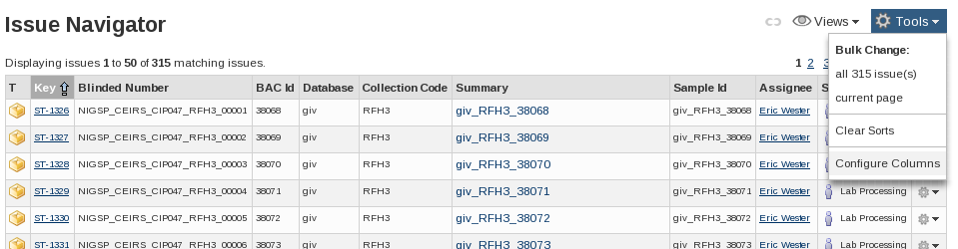
Issue Navigator: Tools drop-down
In the Issue Navigator:
- Select the 'Tools' drop-down menu, situated on the right above the list of issues.
- Select Configure Columns at the bottom of the menu

Issue Navigator Columns Screen
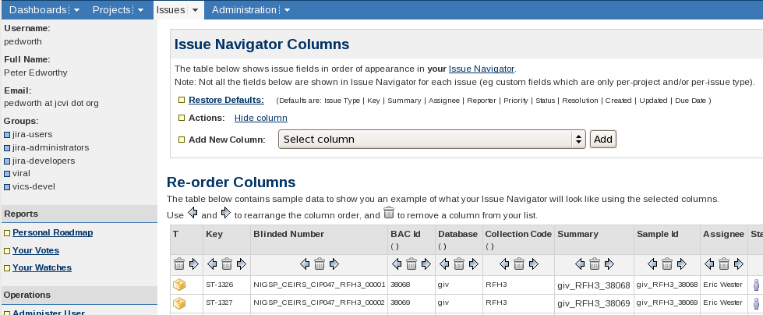
Issue Navigator Columns
This screen allows columns to be added, removed and arranged.
Each column has up to three icons at its top:
Swap the column with the column to its left or right
Remove the column. If a column is accidentally removed it can be re-added via the Add new
Column drop-down.

Adding/re-adding fields is controlled outside the table. Only one field can be added at a time, the field is selected using the 'Select Column' drop-down menu and then confirmed by click 'Add'.
The menu contains all of the fields in JIRA and so can be quite long. The fields are in alphabetical order and so looking up the exact name of the field (as found on the Issue/Sub-Task's summary view) can save time.
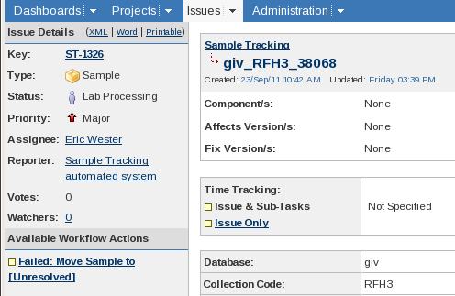
Issue summary view (Sample)
In the above screen shot the field names are 'Database' and 'Collection Code'

Missing Columns
Issue Type specific fields are not shown in the Issue Navigator unless that Issue Type has been explicitly selected. e.g. For the Collection Code to be visible 'Sample' must be among the Issue Types selected. Explicitly setting the issue type is needed even if the search only matches Issues of one Issue Type.

Per Filter Column Layout
The above procedure sets and modifies a user's default column settings. If a search is saved in the Issue Navigator it can then have its own column layout associated.
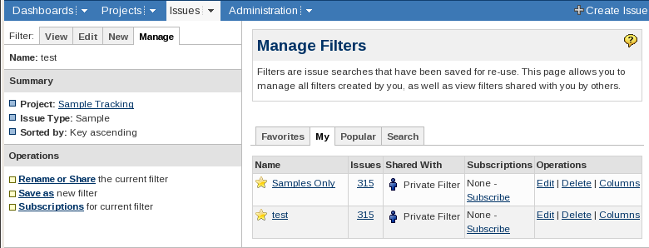
Issue Navigator - Manage Filters
The 'Columns' link under Operations opens the same 'Issue Navigator Columns' page.

